HOME ACTIVITY PACK
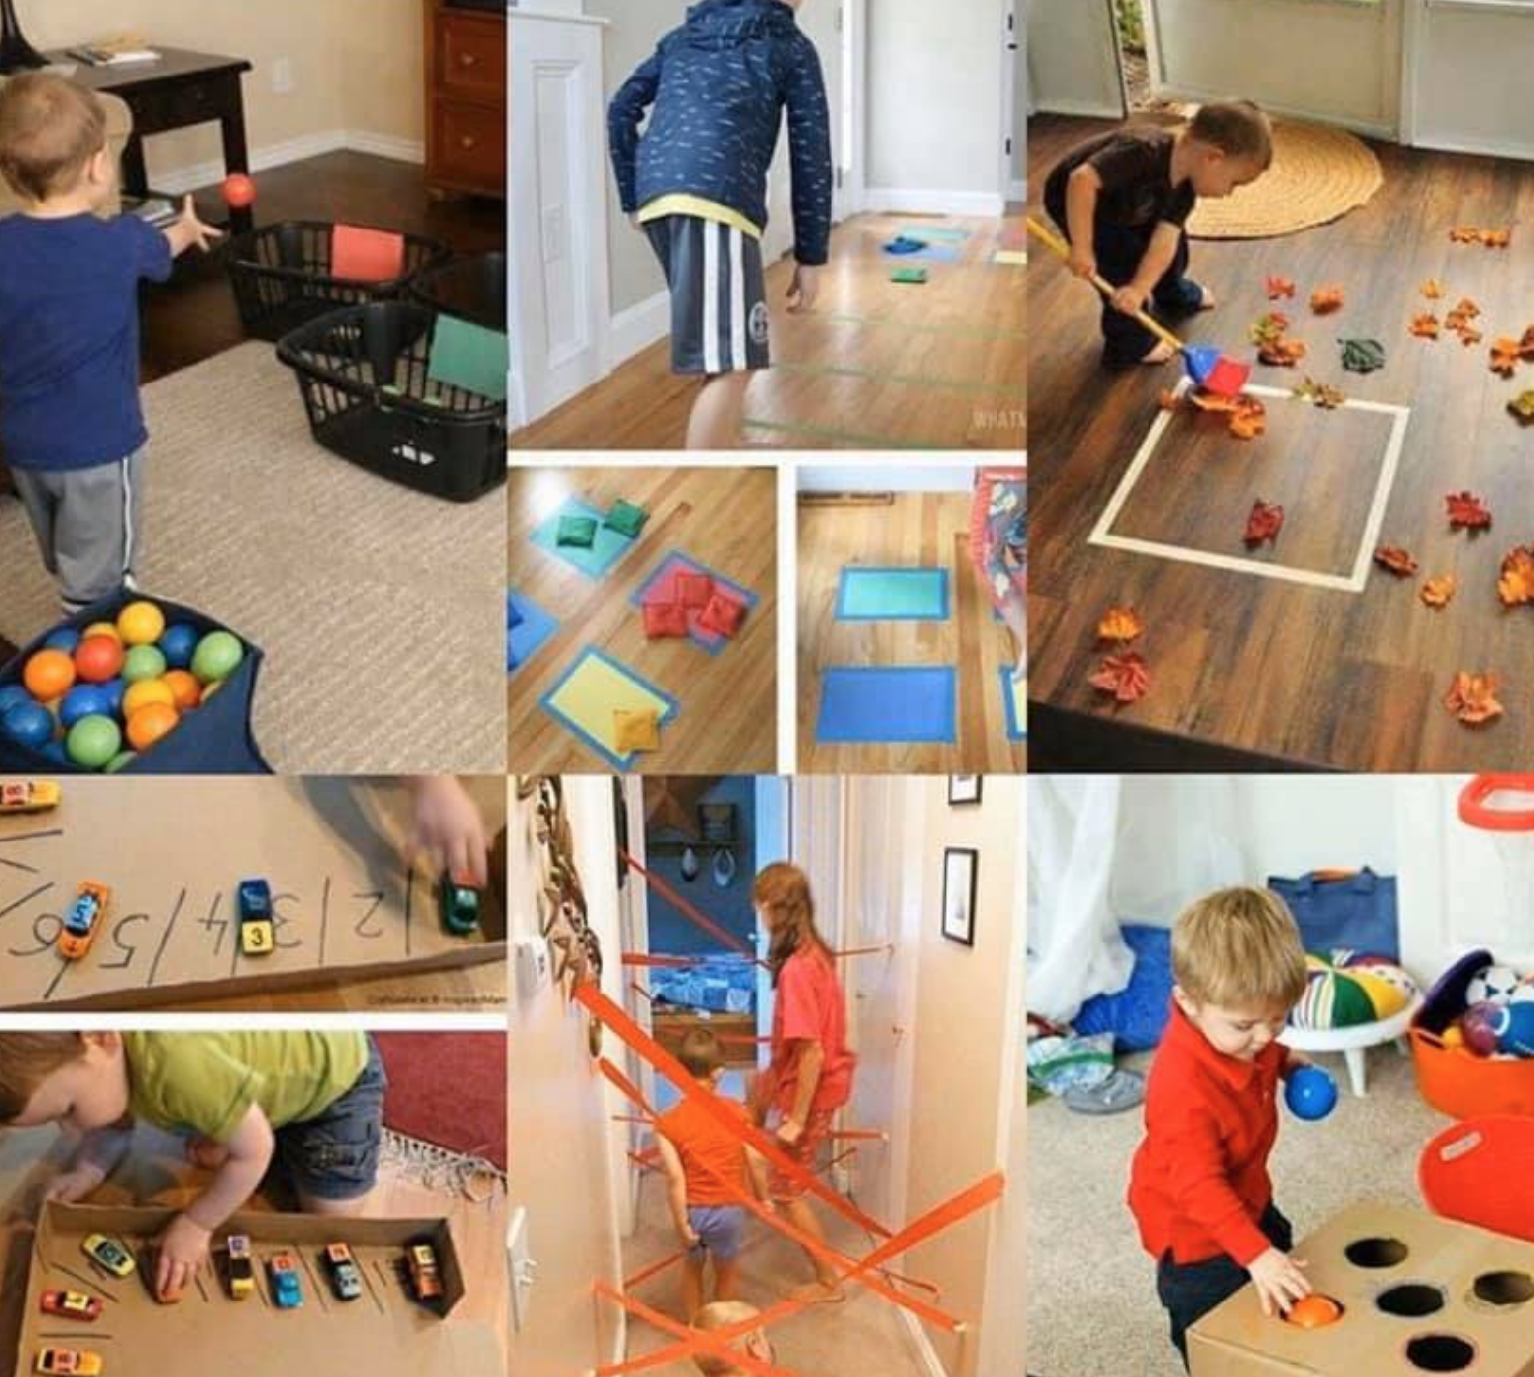
Providing a Fitter, Healthier & Happier future!
FREE RESOURCES Due to school closures Time 4 Sport are supporting everyone with the opportunity to access a variety of PE, PA, and sports content. Encouraging children/families to be fitter, healthier and happier.
SCROLL DOWN for loads of different ideas for playing at home.

We at Time 4 Sport will also be uploading a daily #T4Schallenge on our social media channels. Please take time to like, follow and subscribe now, so you see these updates on your feeds.

www.facebook.com/time4sportuk

www.twitter.com/time4sportuk

www.instagram.com/time4sportuk

Youtube Link
Change 4 Life :

Start making healthier changes today!
Here are a few things to get you started, just click the green links:
- sign up and join Change4Life
- download the Food Scanner app on Google Play or Food Scanner app on the App Store
- browse our recipes
- play one of our 10 Minute Shake Up games
- learn how to make a sugar swap
A GOOD WAY TO ENSURE YOU STAY FIT AND HEALTHY IS TO KEEP A RECORD OF WHAT YOU EAT, DRINK & HOW MUCH EXERISE YOU DO.SEE BELOW THE FOOD & FITNESS LOG! IT IS RECOMMEDED CHILDREN DO 60 MINUTES OF EXERCISE A DAY AND 30 X 5 FOR ADULTS. SEE THE SPECIFIC GUIDELINES HERE: 0-5, 5-18, 19-65 & 65+.
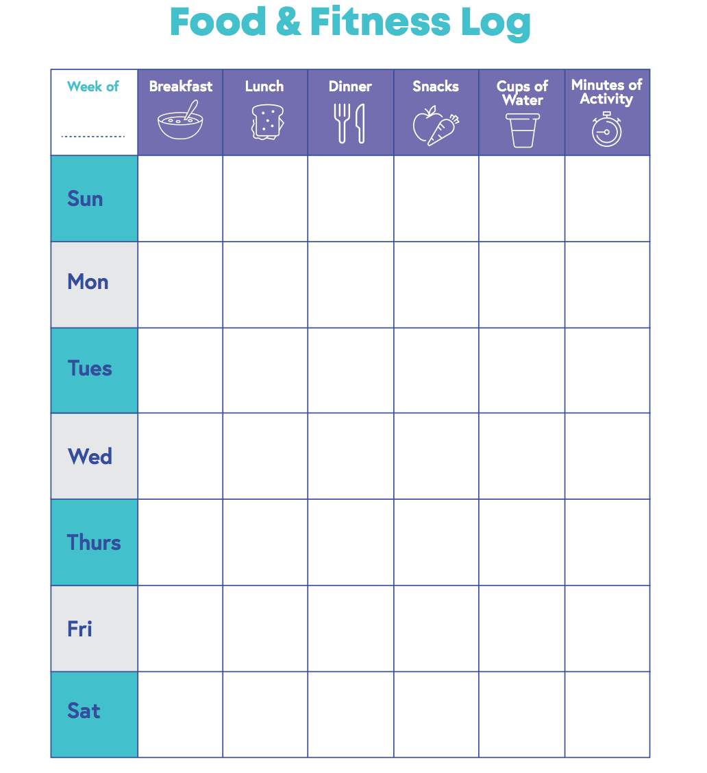

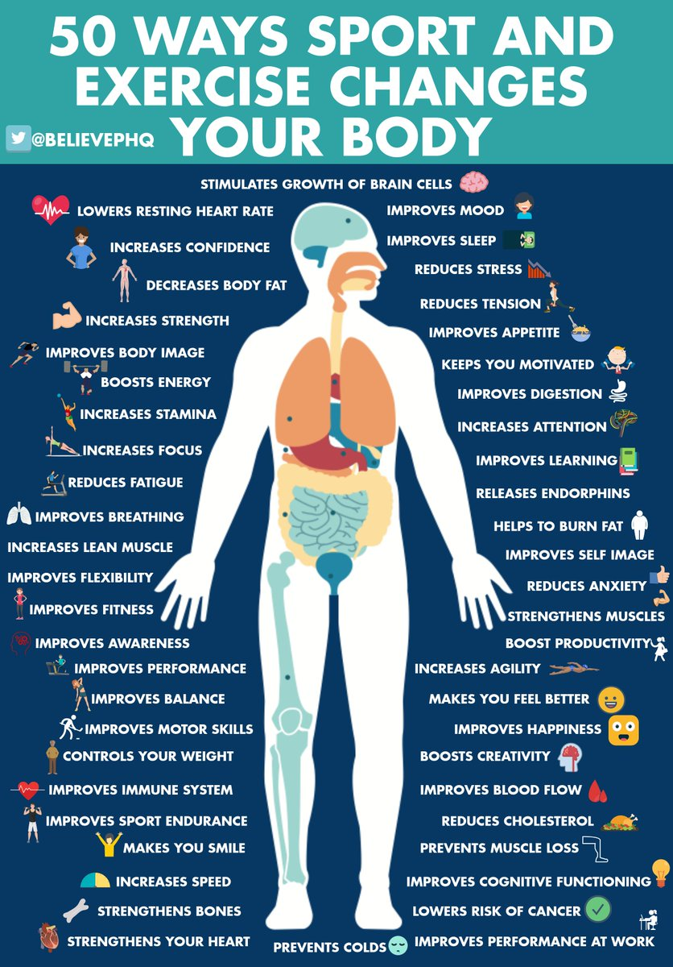

RECEPTION
CLICK THE LINKS FOR SOME GREAT VIDEO BASED IDEAS.
DANCE
Just Dance 2018 - Waka Waka This Time For Africa
https://www.youtube.com/watch?v=gCzgc_RelBA
FITNESS
Kids Beginners Workout | The Body Coach
https://www.youtube.com/watch?v=mhHY8mOQ5eo
YOGA
Mini the Puppy | Cosmic Kids Zen Den - Mindfulness for kids
https://www.youtube.com/watch?v=K7FUbTac_ds

Yr1:

DANCE
Just Dance 2018 - Waka Waka This Time For Africa
https://www.youtube.com/watch?v=gCzgc_RelBA
FITNESS
5 Minute Move Featuring Betsy | The Body Coach TV
https://www.youtube.com/watch?v=u0_1QBQ8Syk
YOGA
Thought Bubbles | Cosmic Kids Zen Den - Mindfulness for kids
https://www.youtube.com/watch?v=xUUq0HuSLS0

Yr2:
DANCE
Let's Dance: I am Alive - will.i.am
https://www.youtube.com/watch?v=2pgR87RVD14
FITNESS
5 Minute Move | Kids Workout 1 | The Body Coach TV –
https://www.youtube.com/watch?v=d3LPrhI0v-w
YOGA
Yes You Can! | Cosmic Kids Zen Den - Mindfulness for kids
https://www.youtube.com/watch?v=jzYtNWjQiK0

Yr3:
DANCE
Macarena. Just Dance 2015
https://www.youtube.com/watch?v=zyIXQsDY9NE
FITNESS
5 Minute Move Featuring Francesca | The Body Coach TV
https://www.youtube.com/watch?v=hvJXQT4gowg
YOGA
Popcorn the Dolphin | A Cosmic Kids Yoga Adventure!
https://www.youtube.com/watch?v=YR1OxBk8BF4

Yr4:
DANCE
Just Dance 4 What Makes You Beautiful
https://www.youtube.com/watch?v=dpY4ZTV7Fm0
FITNESS
Active 8 Minute Workout Featuring Alfie | The Body Coach TV
https://www.youtube.com/watch?v=EXt2jLRlaf8
YOGA
Cosmic Kids Yoga Disco | Washing Machine Song!
https://www.youtube.com/watch?v=dw-0bmtDPnk

Yr5:
DANCE
Mambo No 5 - Just Dance Summer Party
https://www.youtube.com/watch?v=z_Sv7IQwBGo
FITNESS
Active 8 Minute Workout Featuring Izzy | The Body Coach TV
https://www.youtube.com/watch?v=YIB2SJnBHBQ
YOGA
Harry Potter and The Philosopher's Stone | A Cosmic Kids Yoga Adventure!
https://www.youtube.com/watch?v=R-BS87NTV5I
Yr6:
DANCE
FRIENDS by Marshmello & Anne-Marie | Just Dance 2019
https://www.youtube.com/watch?v=Naj1SGmW0h0
FITNESS
Active 8 Minute Workout Featuring Harry | The Body Coach TV
https://www.youtube.com/watch?v=TUp2_VAHIrI
YOGA
Minecraft | A Cosmic Kids Yoga Adventure!
https://www.youtube.com/watch?v=02E1468SdHg

…………..

FAMILY FITNESS CARDS

Great physical activity challenge cards for all the families.

Greenacre Sports Partnership Cards

Wow Activity Cards

OTHER ADDITIONAL LINKS:

Ball Games

Indoor Energy Games

Sesame Street Activities

Year 1 & 2 Cross Curricular Super Movers

Year 3, 4, 5 & 6 Cross Curricular Super Movers

Youth Sport Trust Free Home Resources.

Go Noodle Activity Channel
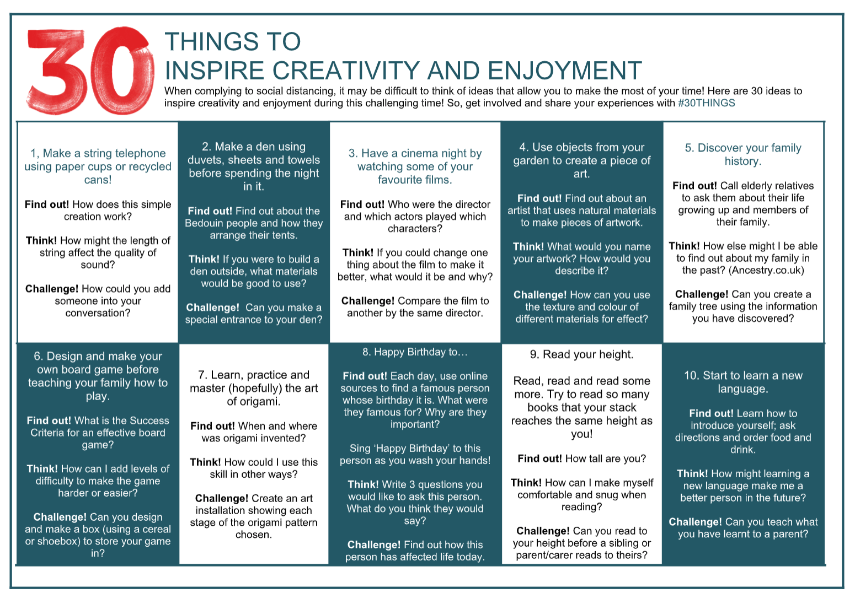
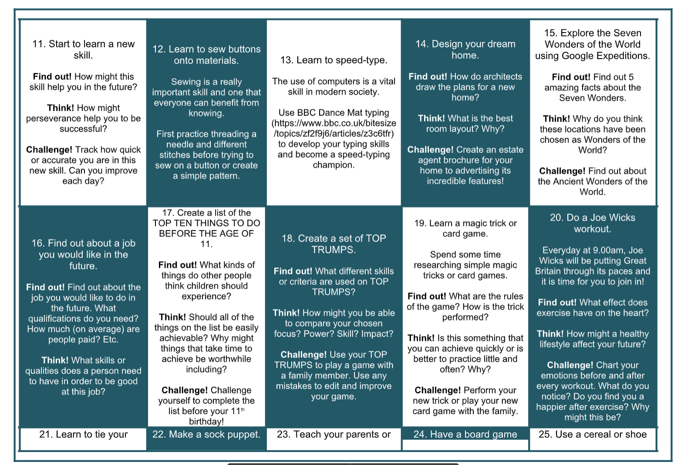

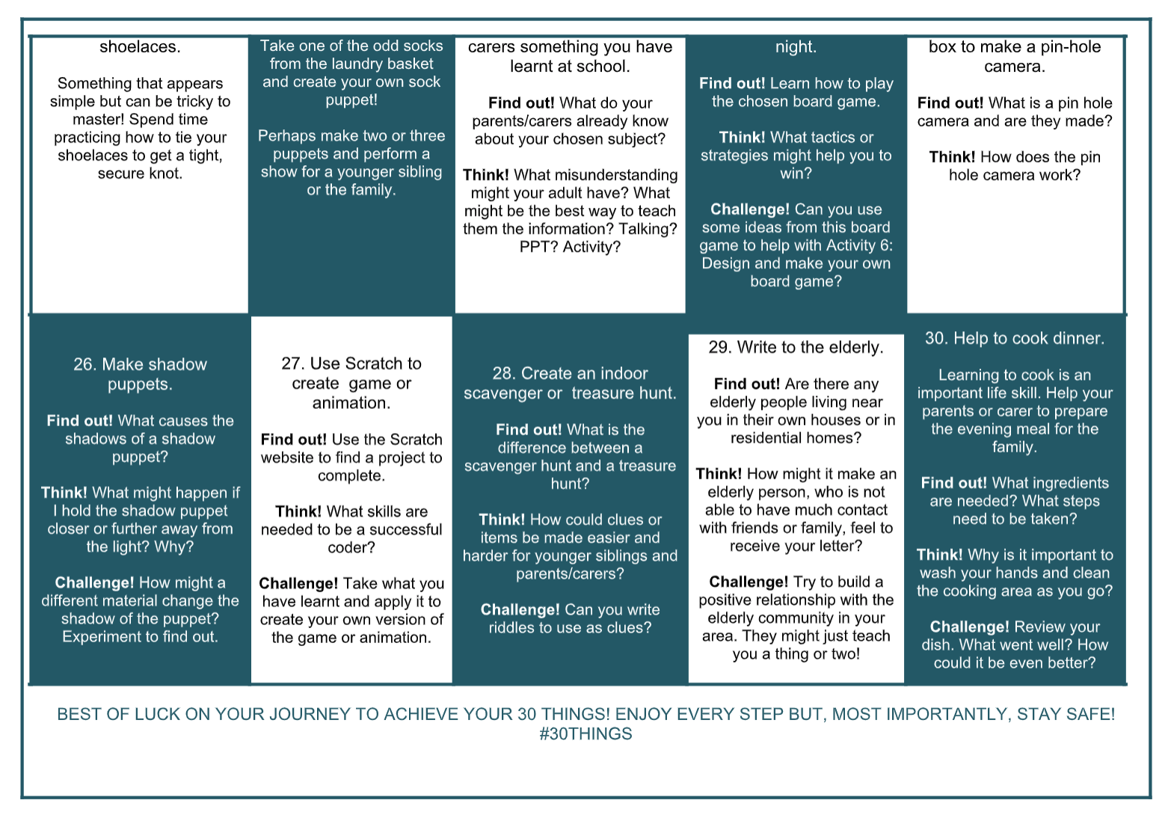

WE LOVE ALL LOVE A GAME OF MONOPOLY RIGHT?
WHY NOT PLAY FITNESS MONOPOLY WITH THE FAMILY!

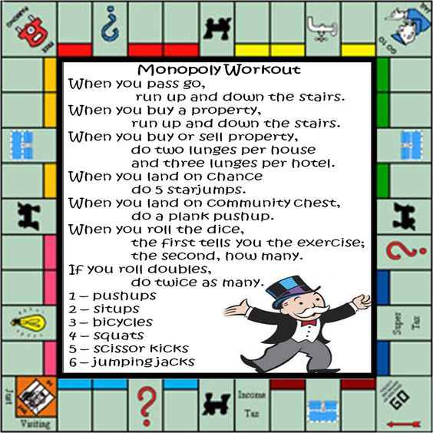

KEY WORKER HOLIDAY CLUBS.

With how things are now, we aren’t 100% sure how the Easter holiday delivery will look. However we at Time 4 Sport will aim to support families as much as possible and potentially may be able to deliver some Key Worker Holiday Clubs within Staffordshire.

Any updates on this will be put out via our social media channels. Or if you would like to be added to our mailing list please click on the link below and complete your details.

ADD ME TO THE MAILING LIST

We hope you enjoy all resources provided. Remember if we stay positive, do our best and all work together we can get through this.
Wishing you all good health and happiness.

The Time 4 Sport Team!

